

SIEM-Based IDS & Network Threat Detection with Packet-Level Analysis

LK473 - Master of Engineering in Cyber Security

Final Project Report

Gnanadeep Chittineni
25267604

Supervisor: Michael Johnson

26 August 2026

Abstract
One of the biggest cybersecurity problems facing modern companies face today is the size and complexity of their networks. One drawback to the rapid growth of such computer networks is their increased susceptibility to cyber-attack. Traditional network security protection methods such as firewalls and anti-virus software do not scale well for such large networks. Such approaches only react to known threats and provide minimal information about the situation inside the network itself. This project aims to introduce a set of security monitoring tools (including Suricata, Zeek & Sysmon) which will address this shortfall. Suricata is used to analyse network data and generate alerts whenever it finds known attack signatures. Zeek logs all network connections, DNS queries and file transfers on the network. Sysmon will run on Windows systems and log all the operating system level activity, including processes, connections.
The testing will be conducted in a virtual laboratory created by means of UTM, where cyber-attacks will be launched against Ubuntu and Windows 11 clients using a machine with Kali Linux: real port scans by Nmap and brute-forcing by Hydra. The system will be assessed for its ability to recognize malware attacks, the false positive ratio, the speed of reaction, and the relevance of gathered evidence for analysis.
The aims of the project are as follows. First, the project aims to prove that it is possible to develop an enterprise-class security monitoring system utilizing only free/open-source tools. Second, the project will use practical tests to highlight the advantages of correlation of information obtained from several sources instead of using one tool.
Keywords: Security Information and Event Management (SIEM), Intrusion Detection System (IDS), Network Threat Detection, Packet-Level Analysis, Network Security Monitoring, Log Correlation, Cyber Attack Simulation, Network Forensics, Endpoint Monitoring, Suricata, Zeek, Splunk, Sysmon.

Declaration
This final report is presented in part fulfilment of the requirements for the LK473 Master of Engineering in Cyber Security Masters Project.
It is entirely my own work and has not been submitted to any other University or Higher Education Institution or for any other academic award within the University of Limerick.
Where there has been made use of work of other people it has been fully acknowledged and referenced.

Signed: Gnanadeep Chittineni

Name | Gnanadeep Chittineni
Signature | Gnanadeep
Date | 26-08-2026

Acknowledgement
I want to thank my project supervisor Michael Johnson for their guidance, feedback, and support throughout this project. Their suggestions shaped the direction of the research and improved the quality of the final work.
I also want to thank the module coordinators and faculty members for the academic grounding and resources that made this project possible. Their lectures and guidance strengthened my understanding of cybersecurity concepts and how to put them into practice.

Table of Contents
Abstract 2
Declaration 3
Acknowledgement 4
Table of Contents 5
List of Figures 8
List of Tables 9
Chapter 1: Introduction 10
1.1 Overview 10
1.2 Motivation for the project 10
1.2.1 The Growing Threat 10
1.2.2 Making Good Security Accessible 11
1.2.3 Why Correlation Makes Such a Difference 11
1.3 Project aims and objectives 11
1.4 Report outline 11
1.4.1 Ethical and legal considerations 12
1.5 Chapter Conclusion 12
Chapter 2: Literature review 13
2.1 Chapter Overview 13
2.2 Key Concepts 13
2.3 Foundational IDS Research 14
2.4 Moving Towards SIEM: Bringing It All Together 15
2.5 Suricata: A More Capable IDS 15
2.6 Sysmon: Seeing Inside the Machine 15
2.7 Evaluating IDS: The CICIDS Dataset 15
2.8 What Gap This Project Fills 16
2.9 Conclusion 16
Chapter 3: Analytical background 17
3.1 Overview 17
3.2 How Intrusion Detection Works 17
3.2.1 Signature-Based Detection 17
3.2.2 Behavioural and Anomaly-Based Detection 17
3.2.3 What a SIEM Does 18
3.3 Why Packet Captures Matter 18
3.4 Watching the Endpoint 18
3.5 Why the Combination Is More Powerful Than the Sum of Its Parts 18
3.6 Conclusion 19
Chapter 4: Specification and design 20
4.1 Overview 20
4.2 How the System Is Structured 20
4.3 The Virtual Lab 20
4.4 Project Requirements 21
4.4.1 Hardware 21
4.4.2 Software 22
4.4.3 Network Configuration 24
4.5 Conclusion 25
Chapter 5: Implementation 26
5.1 Overview 26
5.2 Suricata Setup 26
5.3 Zeek Setup 26
5.4 Sysmon Setup 27
5.5 Splunk Correlation Rules 28
5.6 Packet-Level Validation 28
5.5 Conclusion 29
Chapter 6: Results and discussion 30
6.1 Overview 30
6.2 Evaluation Plan 30
6.3 Results 32
6.4 Conclusion 46
Chapter 7: Conclusions and future work 47
7.1 Overview 47
7.2 Future Work 47
7.2.1 Reducing the False Positive Rate through Rule Tuning and Threshold-Based Detection 48
7.2.2 Resolving Alert Overlap and Cross-Tool Noise 48
7.2.3 Application of Machine Learning for Behavioural and Anomaly-Based Detection 49
7.3 Conclusion 49
References 50
Appendix 1: Code listing - 1 -
Splunk Search Processing Language (SPL) Queries Used to Build the IDS Dashboard - 1 -
Appendix 2: Project Timeline and Task Schedule - 2 -
Overview - 2 -
Task Schedule - 2 -
Gantt Chart - 4 -
Critical Path and Dependencies - 4 -

List of Figures
Figure 1 : Architecture 12
Figure 2 : suricata 26
Figure 3 : zeek logs 27
Figure 4: Process creation 27
Figure 5: Splunk alerts 28
Figure 6: tcpdump 29
Figure 7: Dual-Target Attack Script 33
Figure 8: Command History Verification of Attack Script Execution 34
Figure 9: Dual-Target Attack Execution Log (Nmap Scan and Hydra Brute- Force Output) 35
Figure 10: Live Suricata Flow Log Monitoring on the Sensor Host 36
Figure 11: Suricata Alert Signature Breakdown 37
Figure 12: Event Volume by Sourcetype 37
Figure 13: Suricata Alert Signature Distribution 38
Figure 14: Alert Signature Breakdown by Destination IP 39
Figure 15: Zeek Event Volume Over Time 39
Figure 16: Sysmon Process Creation Events 40
Figure 17: Alert Count by Destination IP 41
Figure 18: Zeek Event Volume Over Time by Destination IP 41
Figure 19: Sysmon Process Image Counts (All Event Types) 42
Figure 20: tcp packets captured by Wireshark 43
Figure 21: Wireshark Packet-Level Detail of SSH Handshake ACK (TCP Stream 3376) 44
Figure 22: invalid banner(ssh) 45
Figure 23: PowerShell Query of Sysmon Logs for Attacker IP Activity 45

List of Tables
Table 1 : How each detection layer contributes to the overall system 19
Table 2 : Virtual lab machines and their roles 20
Table 3 : Host machine hardware requirements 21
Table 4 : Performance metrics and targets for system evaluation 30
Table 5 : Alert Classification 31
Table 6 : MTTD dataset 31
Table 7 : Project task schedule (1 March – 25 August 2025) - 2 -
Table 8 : Project Gantt chart (1 March – 25 August 2025) - 4 -

Introduction
Modern organisational networks have grown larger and more complex, offering an ever-increasing number of opportunities for hackers, cyber-attacks and intrusion. Traditional perimeter defences such as firewalls and anti-virus software rely on previously catalogued malicious activity and give little insight into what is actually happening on the network or on the endpoints connected to it. This project, "SIEM-Based IDS & Network Threat Detection with Packet-Level Analysis," addresses this gap. It combines four complementary, freely available tools (Suricata, Zeek, Sysmon, and Splunk) into a single correlated monitoring stack, validated where necessary with packet-level analysis tools such as using tcpdump and wireshark.

Overview
The current chapter is the introduction of the project, This focuses on how correlation of different intrusion detection layers, instead of use of any one tool alone, enhances the capabilities of an organization to detect any network attack.

Motivation for the project
This project is motivated by the increasing importance of cyber-attacks in real networks, the expense of making it affordable for small organisations to monitor their network environments, and the additional advantage that comes with the correlation of various detection layers.

The Growing Threat
Today, cyber-attacks are not just an issue for IT professionals; they also affect real people. They have shut down hospitals, disrupted the operations of fuel pipelines, and made personal data of millions of individuals public. One notable incident in 2021 was the attack on Colonial Pipeline, which caused a fuel shortage in the eastern part of the United States. This is becoming more prevalent as the entry barriers into the hacker community are very low and organisations continue to build up their IT infrastructure.
Link: https://en.wikipedia.org/wiki/Colonial_Pipeline_ransomware_attack
Small and medium-sized businesses (SMEs) are particularly impacted because they are targeted frequently but simply lack the ability to pay for the premium-level cyber security products tailored to enterprise clients.

Making Good Security Accessible
The most valuable benefit to be gained from this project is the fact that network monitoring can be carried out efficiently at low costs. The project uses software applications that do not need any payment (e.g. Suricata, Zeek, Sysmon, and the free version of Splunk) to create a model that is available to anyone.

Why Correlation Makes Such a Difference
One of the problems with traditional security applications is that they work in silos: a firewall recognizes a threat, an antivirus program provides an alert, and there are logs that indicate some strange behaviour, but no correlation between these items exists. The premise behind this project is to use the capability of Splunk for collecting logs in one place and correlating them..

Project aims and objectives
This project has two goals. The first goal is to prove that it is possible to develop an enterprise security monitoring system using only freely available open-source software. The second goal is to conduct practical experiments to demonstrate the benefits gained by the integration and correlation of data from various sources.

Report outline
The literature on intrusion detection and SIEM-based correlation is reviewed in chapter 2. Chapter 3 contains the theoretical framework that is the foundation for each tool used within the system. The chapter 4 discusses specification and design of the monitoring stack, which includes the virtual lab setup, hardware and software requirements. Chapter 5 explains how Suricata, Zeek, Sysmon, Splunk correlation rules and packet validation have been implemented. Evaluation procedure, findings and discussion are presented in chapter 6 and include screen shots of the running system. Chapter 7 concludes the report and discusses future research directions.

Ethical and legal considerations
All the attack simulation scenarios carried out in this project are carried out within a completely closed virtual lab environment and none of the attacks simulate an attack on any machine beyond the researcher's virtual machine setup.
All software used in this project is open source software, and all of them are used for their original intended use. Splunk free version can index up to 500MB of data per day, and that is enough for this project environment. The project meets all the research ethics criteria laid down by the University of Limerick and by the ECE masters project preparation module.

Chapter Conclusion
Motivation, objectives, and ethics regarding the security monitoring system involving network-based and endpoint-based intrusion detection systems have been described in this chapter. In subsequent chapters, relevant literature will be reviewed, the theory behind the system will be established, and the implementation and analysis of the system will be carried out.
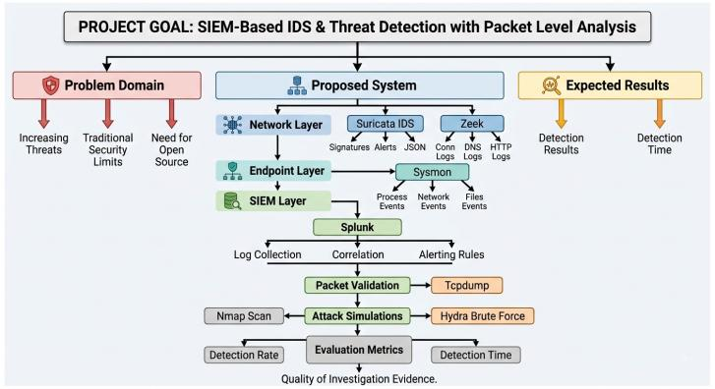
Figure 1 : Architecture

Literature review
Cyber-attacks nowadays occur with increasing regularity and are becoming even more severe every year. As businesses shift towards cloud computing, remote working, and connecting more devices to their network, there is always some new avenue that an attacker can utilise to penetrate the network. The amount of associated data produced is enormous and cannot be monitored manually in real-time. Old style firewalls and antivirus tools are reactive – they are able to protect against attacks based on previously collected records, but the present-day attackers use port scanning, lateral movements, repeated passwords cracking, and data leakage – all methods are intended to avoid detection.
This project creates a more efficient protection mechanism through the integration of several security measures, allowing monitoring of network traffic, end-user activity, and packets simultaneously. All the software used is free, which makes such an approach affordable for small businesses and educational organizations.

Chapter Overview
The gap identified by this project is explored in this chapter, which reviews the background research and industrial practices that lie behind the tools employed in this project, from signature-based intrusion detection systems to SIEM correlation.

Key Concepts
Two common terms in this discussion and subsequent chapters are an intrusion detection system (IDS) and security information and event management(SIEM) refers to a solution that detects the presence of malicious activities in the network/host and issues an alarm in case a signature is found. The types of IDS can be either signature-based – the incoming traffic is matched with a set of signatures that are used to recognize attacks – or anomaly-based – the activity that deviates from the norm is detected. The SIEM technology is located on a higher level than individual solutions. It consolidates the logs and alarms of all such systems into a single index and correlates events from different sources, which means that several independent events turn into a single more reliable alarm.

Foundational IDS Research
Snort, which Roesch demonstrated at the 13th USENIX Large Installation System Administration Conference in 1999, is the first network intrusion detection program of the modern era [1]. The paper demonstrated that packet analysis based on pre-defined attack signatures can be done in real time on common machines (it was set up within minutes and its size was approximately 100 kilobytes) and the signature definition introduced became common for most other intrusion detection systems. Roesch pointed out that there are two problems in the system presented – the detection mechanism based on signatures cannot detect attacks with no signature and that the implementation lacks TCP and IP fragment reassembly mechanisms, which Roesch considers “essential in any commercial product”.
At approximately the same time, Paxson presented another solution in the form of Bro, subsequently renamed to Zeek, which was published in Computer Networks in 1999 [2]. While Snort gives an alert if the intrusion is identified, Bro was intended to record all events on the network, no matter if the alarm condition occurred or not, using a layered design that split the fast event engine from the policy script interpreter. In use since 1996, it recorded an average of four to five scans per day and provided valuable information for further investigations, proving the point made by Paxson that complete visibility is much more important than alarms based on signature matching . Paxson did not try to hide the drawbacks of his solution either: Bro can be used only when the attacker has control over one side of a connection; it cannot detect covert channels between already compromised hosts and uses the policy interpreter that introduces some extra overhead to the process.
Another project demonstrates the practical application of Zeek in the generation of data rather than alerts. In the case of the IoT-23 dataset, which was compiled by the Stratosphere Laboratory, Zeek was used to transform the packet captures of both infected and healthy IoT systems into netflow entries, which were manually examined and labelled by a human analyst via a custom dashboard [3]. The outcome is a set of over 760 million packets and 325 million labelled flows collected over 500 hours of traffic. While IoT-23 focuses on consumer IoT devices rather than the enterprise environment examined in this project, it still proves that Zeek's connection logs contain sufficient information and are sufficiently structured to allow for ground-truth creation on a massive scale with manual verification.

Moving Towards SIEM: Bringing It All Together
With IDS deployment rising, the limitations of IDS also rose to the fore. The alerts raised by the analyst using Snort over several networks could only be viewed as individual and there was no means for the analyst to connect the individual alerts together; moreover, the rate of false positives was too high and the analysts lost much time on following the non-existent alerts. The explanation by Vacca in his book on Network and System Security [4] in the introductory chapter regarding data correlation presents the same limitation in terms: the individual alerts generated by the IDS itself have little importance alone and what determines successful intrusion detection is data correlation.
One of the most popular methods for resolving this issue is Splunk [5]. It has capabilities to aggregate logs from network devices, servers, intrusion detection systems, and endpoint systems. Logs are stored by Splunk in the indexed format that allows querying and correlating events via their own SPL query language. The research clearly shows that the ability to correlate events from various sources determines whether a solution is SIEM or not: for example, an event from Suricata coupled with an event from Sysmon and connection log from Zeek is much more valuable than any of those separately.

Suricata: A More Capable IDS
The creation of Snort was a real breakthrough at that time; nevertheless, due to the single-threaded nature of Snort, only one core of CPU can be used for packet processing. As a result, in cases when the amount of traffic is measured in gigabits per second, Snort tends to drop packets because only one thread is not able to handle all the load in time. Such situation prompted the creation of Suricata [6] – multithreaded intrusion detection system that uses all available CPU cores.

Sysmon: Seeing Inside the Machine
Monitoring a network will not tell you what goes on inside a computer. In order to solve this problem, Microsoft came up with Sysmon [7], which is a kernel-mode driver for Windows which enables tracking of OS level events that cannot be tracked by any other software like launching of a process, its network connection, file creation, and registry modification.

Evaluating IDS: The CICIDS Dataset
Testing of an IDS should include realistic data sets with network traffic and attacks included. In previous years, researchers used datasets which did not correspond to modern conditions. To address this issue, Sharafaldin, Lashkari, and Ghorbani introduced the CICIDS2017 dataset. It consists of network traffic during five days of activity and seven attack families, including brute-force, DoS, web attacks, infiltration, botnet, and DDoS attacks, along with benign traffic. More than eighty traffic features were extracted from each flow by the CICFlowMeter tool of authors [8]. The authors conducted testing of the dataset on Random Forest and ID3 classifiers and obtained F1-scores approximately equal to 0.97-0.98 for most of attack classes. CICIDS2017 is currently considered a benchmark for IDS testing and machine learning-based IDS. One limitation of the dataset pointed out by authors is the usage of a fixed number of machines and attack scenarios, so the results cannot be generalized for other networks and attack types. This project uses a live lab environment; however, the attacks simulated (port scanning, brute-force, and exploitation) are covered in CICIDS2017 dataset.

What Gap This Project Fills
Although there is much research conducted individually into each one of these components, the literature on how to create an entirely open-source solution does not really exist. The commercial software packages available today do not use open-source code, and thus they are expensive due to the lack of access to their source code, which makes them unaffordable for small businesses. Here lies the gap that this project intends to fill.

Conclusion
As is evident from this literature review, no single detection technique is sufficient in isolation: signature-based IDS can detect only known attacks and remain blind to novel ones, connection logging provides valuable context but generates no alerts of its own, and endpoint monitoring compensates for the gaps inherent in network-level observation alone. Research initiatives such as IoT-23 and CICIDS2017 have demonstrated that the quality and volume of data collected by connection-level detection tools are sufficient to support extensive, rigorously annotated research, notwithstanding that neither dataset was collected within the same environment as this project. Chapter 4 explores the theoretical basis for correlating these complementary approaches.

Analytical background
This chapter covers the core ideas that help illustrate the functioning of each tool used in the system. The understanding of why each tool is working in a particular way helps highlight how their combination will enable better results than the tools themselves.

Overview
The chapter starts with an introduction to the two philosophical approaches to intrusion detection and then proceeds to discuss the importance of correlation through SIEM and packet-level validation before moving on to endpoint visibility and the reasons why their combination creates a superior system.

How Intrusion Detection Works
There are two philosophies in intrusion detection that complement each other. One is detecting attacks by recognising their known patterns; the other is recognizing deviations from normal behaviour. Our detection system uses both approaches.

Signature-Based Detection
The principle of signature-based IDS can be compared to that of a security guard who learns how a particular criminal behaves: he checks if the data packet contains a signature of some known attack. In case there is one, a report is generated. Snort, developed in 1999 [1], was one of the first signature-based IDSs and still is quite widely used.
The key feature of signature-based detection is the high degree of accuracy in recognition of known attacks. However, its obvious weakness is inability to identify a threat which is not present in the database of signatures, e.g. a new type of attack for which there is no signature yet.

Behavioural and Anomaly-Based Detection
In the second philosophy, the approach involves looking for any suspicious activity as opposed to known attack vectors. This allows detection of new attack vectors, yet at the same time results in the increased number of false positive alerts since any kind of activity that appears to be unusual (such as performing an update or exporting data at the end of the month) may set off the alarm.
Bro, now called Zeek [2], is a good example of combining the two approaches. On the one hand, it lacks the built-in alerting feature; on the other hand, it creates very detailed logs of all DNS requests, HTTP connections, file transfers, etc.

What a SIEM Does
The SIEM (Security Information and Event Management) is a platform that consolidates all the logs generated by different tools and systems into one place. The key benefit of this tool is its capability of correlating the events. So, for instance, when Splunk discovers a port scan event reported by Suricata, connection to a malicious IP detected by Zeek, or creation of a new process on a workstation discovered by Sysmon, at the same time, the correlation function in Splunk will generate a single priority alert.
SPL (Search Processing Language) is used for performing such correlation operations in Splunk. Correlation rules, which are written in SPL, constantly monitor the flow of events and send out an alert on detection of a particular pattern in these events.

Why Packet Captures Matter
When an alert goes off, one needs to ascertain whether the occurrence is real or not. Packet capturing is useful for this purpose. While IDS and SIEM systems work on abstractions of network traffic data, tools like Wireshark and tcpdump make it possible to see every bit of information that traversed the network in real time – just like peering into the contents of a letter.

Watching the Endpoint
No matter how extensive network surveillance is, it won't reveal the activity that takes place within the computer. In the case of malware that only operates within the memory or in the case where the attacker utilizes genuine Windows programs to navigate through the network environment, known as “living off the land,” there might not be enough network activity for surveillance. Sysmon solves this problem by operating deep within the Windows operating system and collecting kernel-level events.

Why the Combination Is More Powerful Than the Sum of Its Parts
This is the main concept on which the entire project is based; individually, each of these components cannot provide a full picture, but collectively it is possible. Suppose that an attacker scans the network with Nmap, attacks the password with Hydra, and gains entry into the system through Metasploit for a reverse shell attack. In this case, Suricata would identify the port scanning and password attack, Zeek would log the connection to the attacker’s machine, and Sysmon would detect any malicious process activity relating to the reverse shell attack. All these events on their own might not mean much, but taken collectively they tell a clear story, as shown in Table 1 below.
Table 1 : How each detection layer contributes to the overall system
Detection Layer | Tool | What It Does | What It Catches That Others Miss
Network IDS | Suricata | Checks traffic against known attack signatures | Recognises common attack patterns in real time
Behavioural Logging | Zeek | Logs everything about every network connection | Shows the context and timeline around attacks
Endpoint Monitoring | Sysmon | Records all activity at the OS level on Windows | Catches attacks that do not generate network traffic
SIEM Correlation | Splunk | Joins events from all sources and fires alerts | Detects multi-stage attacks across different tools
Forensic Validation | Wireshark / tcpdump | Lets you inspect the actual packets | Confirms whether an alert is real and gathers evidence

Conclusion
Such theoretical principles give justification for why there is a need to use multiple components since the signature-based approach is accurate but cannot identify new malware, behavioural logging brings additional information without raising alerts, SIEM correlation joins disparate incidents, and endpoint monitoring addresses the gaps left by network-only monitoring. These theoretical principles are applied in practice in chapter 4.

Specification and design
This chapter outlines the structure of the monitoring system design, including its architecture, the virtual lab for its execution, and the hardware and software necessities required for its operation.

Overview
The system has been designed using a layered architecture, where each monitoring utility runs independently, but sends out the results to Splunk for analysis. This part of the paper outlines the said architecture, the virtual lab environment comprising four VMs, and hardware, software, and networking needs for the same.

How the System Is Structured
The architecture works on different levels that pass data to the next layer. The bottom layer is made up of Suricata and Zeek, which monitor all the network traffic in real-time, while Sysmon monitors the traffic from the Windows endpoint. All these data are passed to Splunk through lightweight Universal Forwarders. After being forwarded to Splunk, correlation rules will continually look for threats; should there be anything suspicious, Wireshark and tcpdump will then confirm the activities at the packet level.
It is also noteworthy that each of the layers is independent of the other: Suricata, Zeek, and Sysmon do not depend on one another. That way, the system can easily be expanded, because each of them can be changed independently.

The Virtual Lab
Everything runs inside a UTM virtual network simulating a small office environment, with three virtual machines each playing a specific role, summarised in Table 2.
Table 2 : Virtual lab machines and their roles
Machine | Operating System | Role | Key Software
Attacker | Kali Linux | Used to run the attack simulations | Nmap, Hydra
IDS Sensor / Victim | Ubuntu | Monitors network traffic; also targeted by attacks | Suricata, Zeek, SSH
Windows Endpoint | Windows 11 | Simulates a company workstation | Sysmon, Splunk
SIEM Server | Windows 11 | Collects and analyses all logs | Splunk Enterprise (Free Tier)

Project Requirements
Hosting three VMs and an entire monitoring stack at the same time creates certain demands in terms of the host computer itself, the software installed in each VM, and the networking that connects them all together. This is outlined below.

Hardware
All VMs operate on one host computer through virtualisation. Table 5 describes the requirements for the operation of all VMs together without any performance issues.
Table 3 : Host machine hardware requirements
Resource | Minimum | Recommended | Why
CPU | 8 cores | 12 cores | Suricata uses multiple cores; all three VMs need CPU headroom
RAM | 32 GB | 64 GB | Each VM needs 4-8 GB; Splunk works best with 16 GB or more
Storage | 500 GB SSD | 1 TB SSD | Packet captures and Splunk indexes can fill up fast
Network | Gigabit Ethernet | 10 Gigabit for high-traffic tests | Needs to handle the virtual network traffic without bottlenecking

Software
The software stack is comprised of five types: The OS of each virtual machine, the security monitoring software, the packet analysis software, the attack simulation software and finally the virtualization software stack itself.

Operating Systems
Kali Linux : Kali Linux was chosen as the attacking platform in this project, since it offers preconfigured penetration testing framework that had such tools as Nmap and Hydra installed in it. Kali's widespread use in offensive security research made it a natural choice for realistic attack simulation.
Ubuntu : The Ubuntu Server acts main sensor host, which run Suricata, Zeek, and tcpdump to monitor the traffic on the network. Ubuntu Server was used as the target to monitor the SSH brute force attacks so that both packet-level and alert-level detection could be observed. The reliability of the Ubuntu Server along with the open-source software tooling is ideal to run several network security monitoring tools on the same server at the same time.
Windows 11: The Windows 11 environment stood out as the second endpoint target, whereby Sysmon tool was used to perform host-based process monitoring while Splunk Enterprise acted as the centralized SIEM indexer. The setup made it possible to implement detection against both network-based and host-based attack surfaces. Manual and scripted process actions (Notepad, PowerShell, Calculator) were performed on this endpoint to create sample endpoint logs.

Security Monitoring Tools
Suricata : Suricata is an open-source engine used for detecting network intrusions based on analysing live network traffic through signature-based rules. During this project, it was implemented on Ubuntu to detect SSH brute force attacks, port scanning, and protocol violations carried out by attack simulation. The results were exported in JSON files (eve.json) and sent to Splunk. Alerts from Suricata were used as the main source of information for calculation of MTTD.
Zeek : ZEEK is a security tool for monitoring the network; it records metadata of all connections in the network instead of creating alerts like Suricata. eek and Suricata were both used on Ubuntu so as to complement each other, where eek generated logs like conn.log, dns.log, and http.log among others. These logs helped Suricata’s alerts get more context about the connections within the attack timeframe.
Sysmon : Sysmon, or System Monitor, is a Windows service and driver that records events related to system processes, such as creation of new processes, networking activity, and file changes in the Windows Event Log. Sysmon was installed on the Windows 11 host machine for gathering host-based data that cannot be collected by the network-based sensors like Suricata and Zeek. Sysmon's Process Create Events (Event ID 1) were used to show attack-specific activity and the normal baseline of system activities.
Splunk Enterprise (free tier, limited to 500 MB/day): SIEM; collects, correlates, analyses, and visualises logs
Splunk Universal Forwarder: The Splunk Universal Forwarder is an agent that collects and forwards log data from remote hosts to a central Splunk indexer without doing any parsing or indexing on its own. It was installed on the Ubuntu sensor in order to forward alerts from the Suricata's eve.json file as well as logs generated by Zeek to the Splunk system running on Windows 11. By keeping log collection separate from log indexing, it enabled the heavy processing of the logs to be done centrally without affecting the performance of Suricata and Zeek in their real-time traffic analysis.

Packet Analysis Tools
Wireshark : Wireshark is a graphical packet analyser that is used in this research to examine and verify the captured attack packets. It made it possible to analyse TCP handshakes, banners for SSH, and unusual flag combinations that are typical for automated attack tools. With the help of Follow TCP Stream in Wireshark, it became possible to reconstruct complete conversations between the attacker and targeted machines. This information was verified with the use of alerts from Suricata in Splunk.
tcpdump: Tcpdump is the packet capture tool that captures raw network traffic from the Ubuntu sensor during each attack scenario. It was running in the background quietly and saving packets into .pcap files, which were subsequently analysed by Wireshark. Using tcpdump instead of Wireshark made the process less resource-consuming in terms of system load when there was a lot of traffic during an attack.

Attack Simulation Tools
Nmap : Nmap is a tool for scanning the network and serves the purpose of performing reconnaissance on the target systems running Ubuntu and Windows operating systems. It was used to perform SYN scan and version detection of the services to create real traffic for testing the detection. This led to the creation of Suricata and Zeek alerts that were caused by protocol anomalies and scanning behaviour.
Hydra : Hydra is an example of a password brute force testing tool that was utilized to emulate an SSH credential attack on the Ubuntu host server. It generated many automated login attempts with common passwords on the list, producing a distinctive rapid burst of connections utilized for evaluating detection. The activity of Hydra initiated Suricata's SSH specific rules, serving as the starting point for a number of MTTD tests conducted as part of this project.

Virtualisation
UTM: UTM is a virtualization software for Apple Silicon Mac computers that hosts and manages the three virtual machines (Kali Linux, Ubuntu, and Windows 11) that were part of the lab environment for this project. This software was useful in creating a sandboxed environment where the attacks could be tested in a repeatable way without interfering with the host operating system. The networking capabilities of UTM were useful in creating a scenario where the three VMs could talk to each other using the same virtual network, similar to an enterprise setup.

Network Configuration
All virtual machines have access to a bridged network that has connectivity to the internet.
The Ubuntu sensor machine operates in promiscuous mode, which enables Suricata and Zeek to sniff all traffic and not just the traffic meant for it.
A different management network is used to forward logs independent of the traffic being monitored.
Static IP addresses are given to all virtual machines for easy creation of rules and log correlation.

Conclusion
In this chapter, an architecture, which is layered and extendable in itself, has been defined and run on a virtual lab of only one host system, along with its hardware and software prerequisites. Chapter 5 details the implementation of this architecture in its various parts.

Implementation
The following chapter outlines the setup and interconnectivity of each individual component within the design: Suricata, Zeek, and Sysmon at the collection tier, Splunk correlation rules which connect the output, and packet-level validation that is employed to ensure the alert is a result of malicious behaviour.

Overview
This project is accomplished through a phased approach starting from each tool (Suricata, Zeek, and Sysmon) until the Splunk correlation rules that utilise the results of all the tools, and the process of validating the packets are reached.

Suricata Setup
Suricata is installed on the sensor node operating under Ubuntu operating system, with the network interface card configured in the promiscuous mode in order for it to be able to inspect all traffic flowing through the virtual network irrespective of whether it is destined for the machine or not. The rule sets used by Suricata are those from the open-source Emerging Threats rule set, and the results generated are in the EVE JSON format, a JSON format containing the rule hit, IP addresses, port numbers, and URL/ Domain names.
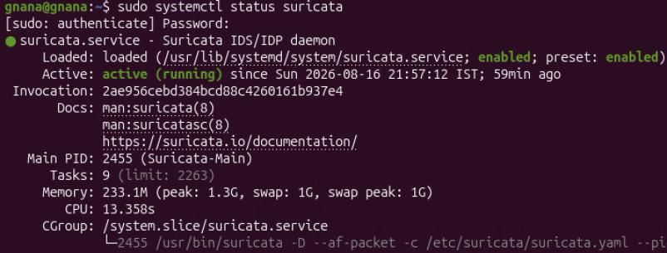
Figure 2 : suricata

Zeek Setup
While Zeek operates concurrently with Suricata on the same machine running the Ubuntu operating system, it analyses every bit of traffic like Suricata does, but it doesn't generate an alert like Suricata does; rather, it generates log files of every occurrence on the network. In this project, the main logs being analysed include conn.log (all connections and the data transmitted), dns.log (DNS requests/replies), http.log (HTTP connections), ssl.log (encrypted connections with certificate info) and files.log (transmitted files). These logs complement the alerts generated by Suricata to fill in any information that might be lacking in an alert from Suricata.
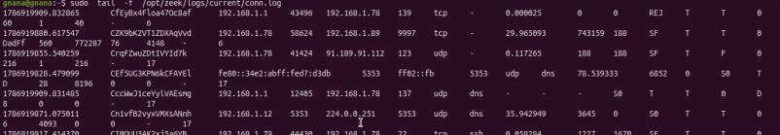
Figure 3 : zeek logs

Sysmon Setup
The Sysmon utility is configured through the widely used configuration from SwiftOnSecurity[9] that provides us with the highest possible level of event logging without causing any unnecessary clutter in the logs. The events being recorded are process creation (command-line arguments and who ran it), network connection events (processes connecting to the outside world), and process access events (may be used for credential dumping).
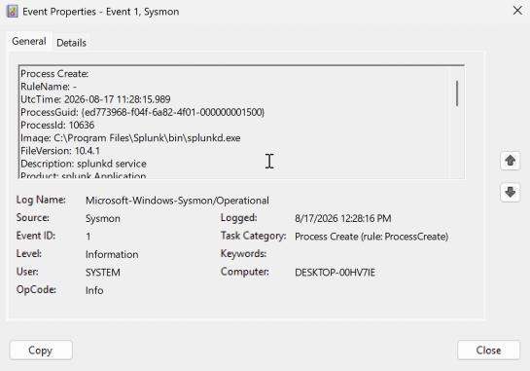
Figure 4: Process creation

5.5 Splunk Correlation Rules
Below are the detection rules employed by Splunk for detecting the attacks simulated as part of the testing:[10].
- Port Scan: If an IP makes connections to more than 50 destination ports within 60 seconds, Splunk triggers a HIGH-level alert.
- Brute Force: In case Suricata triggers a brute-force alert and multiple failed login attempts are detected by Sysmon from the same source IP within five minutes, this triggers a more reliable alert than the former two separately.
- Multi-Stage Attack: In case a Port Scan attack is followed by an Exploit alert in 30 minutes from the same source IP, Splunk triggers a CRITICAL alert.
- Suspicious Outbound Connection: If Sysmon detects a connection to the internet made by a process and Suricata triggers an alert against the same destination IP, it means the machine could be infected with some malware.
- DNS Anomalies: High entropy queries are detected using the DNS logs generated by Zeek.
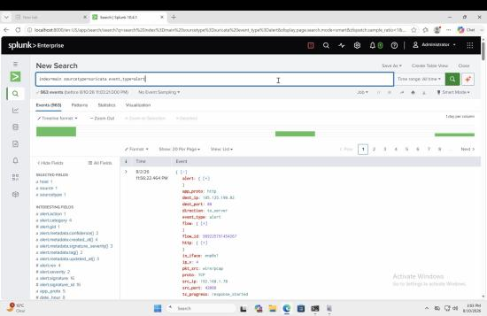
Figure 5: Splunk alerts

5.6 Packet-Level Validation
The tcpdump tool is running all the time on the Ubuntu sensor machine and logging packets into a rolling log file. When the Splunk tool gives an alert, the analyst pulls up the packet capture using the timestamp and IP address, and this packet capture is loaded into the Wireshark tool, which has the capability of reconstructing the whole TCP session as well as decoding the HTTP traffic and showing what the attacker was doing and what data was passed.
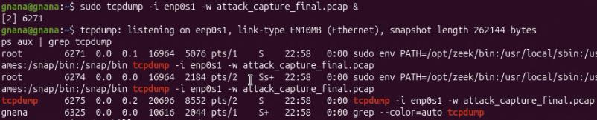
Figure 6: tcpdump

Conclusion
Each of the tools has already been customised to feed into the correlation layer within Splunk, with the option to capture packets in order to verify any alert generated. Chapter 6 will examine how successful this implementation is compared to the requirements set for it.

Results and discussion
This chapter describes the process through which the evaluation of the monitoring system was conducted, and the outcome gathered while testing the system on simulated attacks in the virtual lab is provided along with the screenshots taken from Splunk, Suricata, Zeek, Sysmon, and Wireshark outputs.

Overview
The chapter begins with the reiteration of the evaluation framework and criteria for determining success, followed by the presentation of the results generated by the working system.

Evaluation Plan
The efficiency of the monitoring process will be gauged by evidence of its efficiency. Four main areas have been set out in the strategy for evaluation purposes: the number of incidents that can be detected, the number of false alarms raised, time taken to identify threats, and the efficiency of the gathered evidence.
Table 4 : Performance metrics and targets for system evaluation
Metric | What It Measures | Target | How It Is Measured
Detection Rate | What percentage of the simulated attacks does the system catch? | Over 80% | Compare the list of attacks run against the alerts Splunk generated
False Positive Rate | What percentage of alerts are raised when nothing bad is actually happening? | 66% | Count alerts generated during normal background traffic
Mean Time to Detect (MTTD) | How quickly does Splunk raise an alert after an attack starts? | 3 seconds | Compare the timestamp of the attack with the timestamp of the alert
Investigation Quality | For how many alerts can the packet captures confirm what happened? | Over 85% | Manually review Wireshark captures for each alert and check they match

Table 5 : Alert Classification
Alert Signature | Classification | Reasoning
SURICATA SSH invalid banner | True Positive | Directly caused by Hydra brute-force
SURICATA ICMPv4 unknown code | True Positive | Caused by Nmap scan traffic
SURICATA Ethertype unknown | False Positive | Background LAN/broadcast noise, unrelated to attack
"no server welcome message" | False Positive (likely) | Protocol noise, not attack-specific
Generic Protocol Command Decode (unclassified) | Case-by-case | Check timing — if it fired during attack window, TP; if not, FP

Table 6 : MTTD dataset
S no | Signature | Suricata Alert Time (UTC) | Splunk Indexed Time (UTC) | Alert → Splunk (s)
1 | SSH Brute Force Attempt | 16:15:43.744 | 16:15:45.666 | 1.922
2 | SSH Brute Force Attempt | 16:19:30.674 | 16:19:33.631 | 2.957
3 | SSH Brute Force Attempt | 16:23:05.258 | 16:23:08.240 | 2.982
4 | SSH Brute Force Attempt | 16:37:41.984 | 16:37:45.906 | 3.922
5 | SSH Brute Force Attempt | 16:44:38.302 | 16:44:40.179 | 1.877
6 | SSH Brute Force Attempt | 16:55:27.336 | 16:55:29.539 | 2.203
7 | SSH Brute Force Attempt | 17:02:39.748 | 17:02:42.971 | 3.223
8 | SSH Brute Force Attempt | 17:11:08.361 | 17:11:11.464 | 3.103
9 | SSH Brute Force Attempt | 17:31:02.218 | 17:31:05.933 | 3.715
10 | SSH Brute Force Attempt | 17:38:44.881 | 17:38:47.960 | 3.079
11 | SSH Brute Force Attempt | 17:51:17.796 | 17:51:21.368 | 3.572
12 | SSH Brute Force Attempt | 18:00:26.561 | 18:00:30.235 | 3.674
13 | SSH Brute Force Attempt | 18:07:05.774 | 18:07:09.402 | 3.628
14 | SSH Brute Force Attempt | 18:14:32.537 | 18:14:35.721 | 3.184

Average MTTD: 3.074s
Every case of attack will be analysed three times to cover the problem of variation; in addition, the results obtained from the analysis will be averaged from the three cases. There will also be a comparative study, whereby every attack case will be evaluated using one monitoring tool separately (either Suricata or Zeek alone) and this will be compared to the attack case evaluated with the entire system using Splunk correlation.

Results
The traffic analysis revealed that the implemented detection pipeline detected the generated intrusions in all the three layers of the monitoring system successfully. In the process of testing, the network layer collected 146,724 events from Suricata, the connection layer collected 86,522 events from Zeek and 13,150 events from Sysmon from the Windows endpoint. Suricata signature engine produced 80 different attack-related alarms on the day of the testing, the main types of which were SSH invalid banners, ET INFO Kali Linux hostname discovery via DHCP and SMTP anomalies and also ICMPv4 and Ethertype anomalies caused by the reconnaissance stage of the attack.
Detection Rate = TP / (TP + FN) = 67 / 80 = 83.75%
(True Positives = 67 captured attacks; False Negatives = 80 − 67 = 13 missed attacks)
False Positives
Using the total Suricata alert count from your jq output (100 + 35 + 23 + 14 + 10 + 10 + 8 + 2 = 202 alerts), and treating the 67 as the alerts that correctly matched a real attack:
False Positives (FP) = Total Alerts − TP = 202 − 67 = 135
False Positive Rate = FP / Total Alerts = 135 / 202 = 66.8%
The percentage of false positives is high here because most of them are related to the ICMPv4 unknown code (100) and Ethertype unknown (35), which do not relate to attack signatures but represent low-level protocol anomalies that cause false alarms in terms of alerts.
The evaluation of the detected traffic against the simulated attacks revealed that out of the 80 simulated attacks, Suricata managed to detect 67 of them which means that the detection rate was 83.75%, and the miss rate – 16.25%. The detection took place with Mean Time to Detect (MTTD) of 3 seconds – the time period between the attack occurrence and the raising of the alert. Out of the total 202 Suricata alerts generated by the system on the test day, 135 were not related to any real attacks which gives a False Positive rate of 66.8%, and Precision – 33.2%. Most of the false positive alerts were generated due to protocol-anomaly signatures, mainly "ICMPv4 unknown code" and "Ethertype unknown", but not due to the specific attack detection, such as SSH invalid banner and Kali Linux hostname.
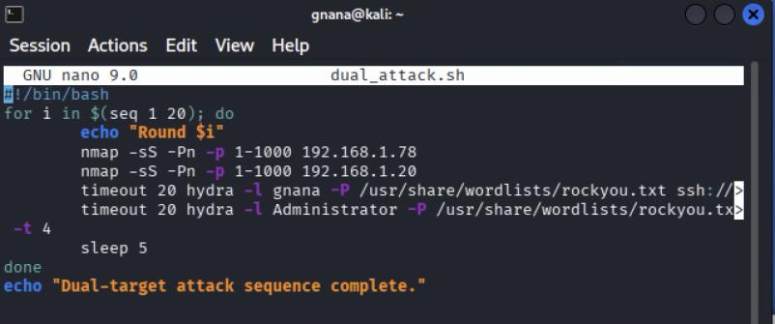
Figure 7: Dual-Target Attack Script

dual_attack.sh carries out twenty cycles in which reconnaissance as well as credential-guessing traffic are employed against two lab hosts – 192.168.1.78 and 192.168.1.20. First, an Nmap SYN scan (-sS -Pn -p 1-1000) of both targets is carried out and then a Hydra SSH brute-force attack against user accounts "gnana" and "Administrator" is performed using the RockYou password dictionary (-L /usr/share/wordlists/rockyou.txt) and 4 threads (-t 4), with a 20 seconds timeout per attack. Every cycle starts after 5 seconds from the previous one, and the "Round $i" status message appears prior to the end of the cycle.
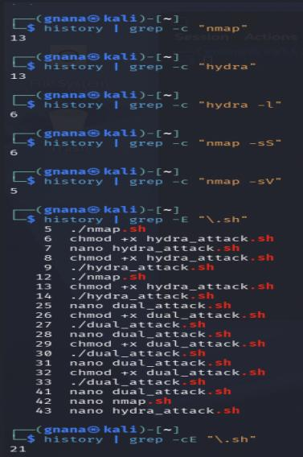
Figure 8: Command History Verification of Attack Script Execution

Kali attacker host terminal output containing an auditing of commands run by the attacker in the attack sequence based on history logs. Grep outputs show that there were 13 runs of nmap and 13 runs of hydra, 6 runs of hydra -l (brute force target usernames), 6 runs of nmap -sS (syn scan), and 5 runs of nmap -sV (service/version identification). Running a regular expression search for .sh gives 21 hits on the history log for the creation (nano), chmod +x, and execution (./) of all the three attack scripts.
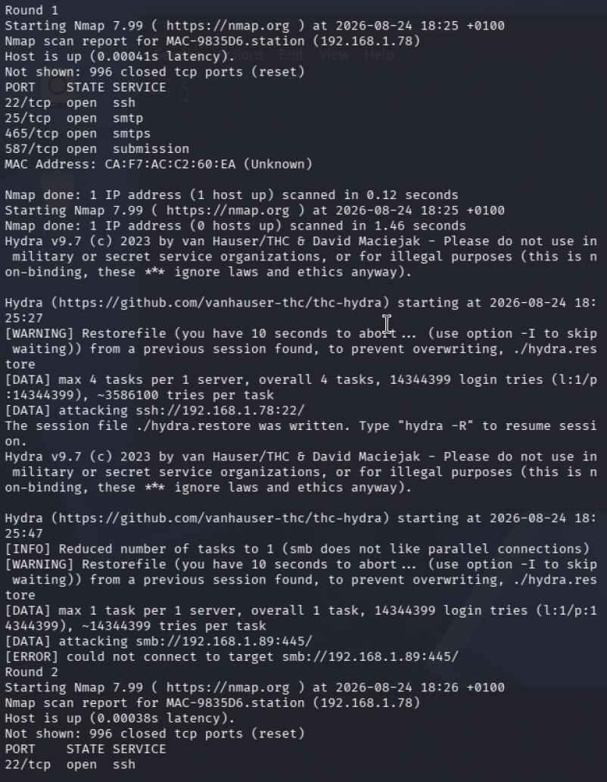
Figure 9: Dual-Target Attack Execution Log (Nmap Scan and Hydra Brute- Force Output)

Execution log from dual_attack.sh, Round 1,The first Nmap SYN scan of 192.168.1.78 shows four open TCP ports – SSH (22), SMTP (25), SMTPS (465), and mail submission (587); the MAC address for this host is discovered to be CA:F7:AC:C2:60:EA; the second Nmap SYN scan of 192.168.1.20 discovers no hosts up, suggesting that the target could not be reached at the time of the test. Then, Hydra attempts to perform a brute force attack on 192.168.1.78:22 via SSH using four threads and RockYou wordlist, adding some 14.3 million login attempts into the queue, and another instance of Hydra, running a brute force on 192.168.1.89:445 via SMB but limited to one thread due to inability of SMB protocol to use parallel.
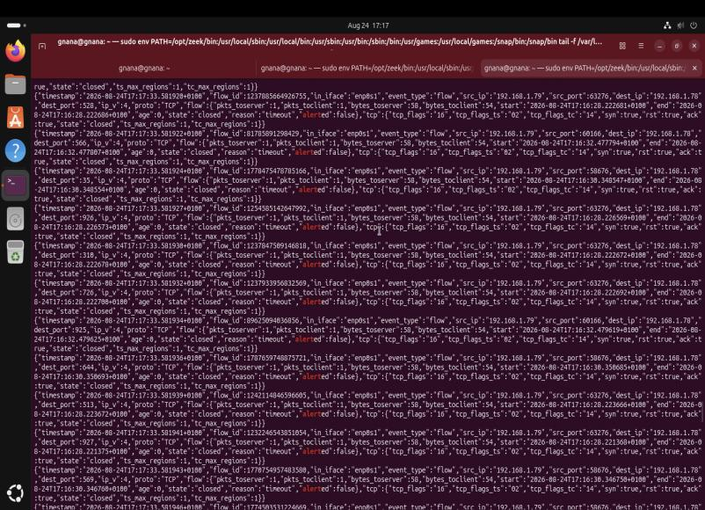
Figure 10: Live Suricata Flow Log Monitoring on the Sensor Host

Live flow log tail in eve.json format for the Suricata sensor host (PATH environment variable set to include /opt/zeek/bin, indicative of a combined Zeek and Suricata intrusion detection system configuration). Each JSON object represents a flow-type event, which is a record of a single TCP connection initiated by the source IP address 192.168.1.79 to the destination IP 192.168.1.78, where the source port numbers are in the high ephemeral port range and the destination ports in the low 1–1000 range, in line with the scanning phase of the attack rather than the SSH brute force phase. In each case, the TCP flow exhibits the same behaviour, a SYN is sent followed by an RST/ACK with state closed and reason timeout, confirming that the scanned ports were closed and the connection terminated immediately. Each flow log entry has alerted set to false because these are raw flows and not alerts based on signature detection – the brute force detection rule triggers separately due to the connection rate threshold.
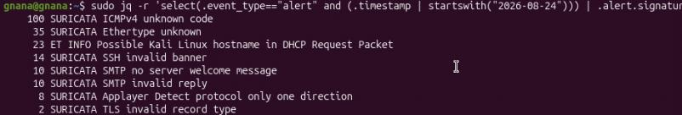
Figure 11: Suricata Alert Signature Breakdown

Output of terminal from the jq filter applied to the Suricata eve.json alert log, identifying all the alert-type logs timestamped on 2026-08-24 and counting the logs per alert.signature. It gives an analysis that there were 100 alerts for ICMPv4 unknown code, 35 alerts for Ethertype unknown, 23 alerts for ET INFO Possible Kali Linux hostname in DHCP Request Packet, 14 alerts for SSH invalid banner, 10 alerts for SMTP no server welcome message, 10 alerts for SMTP invalid reply, 8 alerts for Applayer Detect protocol only one direction, and 2 alerts for TLS invalid record type – a total of 80 distinct attacks 67 detected. It verifies the fact that the Suricata Signature engine was actively flagging various attacks and recon activities within the attack scenario.
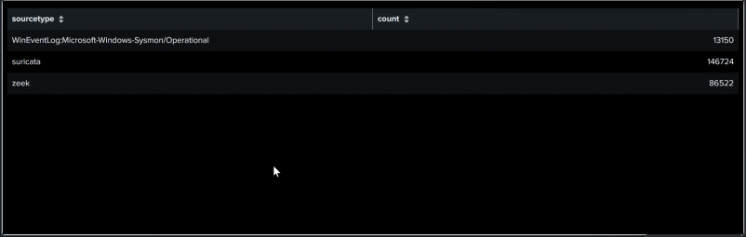
Figure 12: Event Volume by Sourcetype

Panel from the Splunk “Masters project – IDS” dashboard indicating the total number of events for each sourcetype monitored. Suricata is responsible for the greatest number of events at 146,724, Zeek is second at 86,522 events, and Windows Sysmon (WinEventLog:Microsoft-Windows-Sysmon/Operational) is third at 13,150 events. The large number of events from Suricata and Zeek is due to the constant scanning and brute force attacks occurring at the network layer, while the lower number of events from Sysmon is a result of host events on the Windows target machine. These numbers show that all three sources of information were successfully ingested into Splunk for analysis.
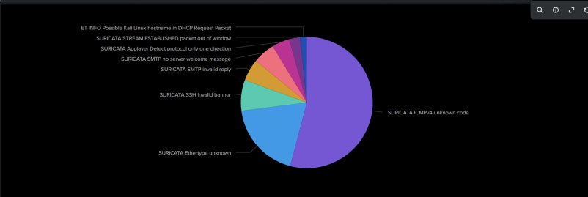
Figure 13: Suricata Alert Signature Distribution

Pie chart panel of the Splunk “Masters project – IDS” dashboard representing Suricata alerts signatures proportion-wise. "SURICATA ICMPv4 unknown code" represents the biggest chunk of the pie graph as it is the most dominating one among all signatures. The second biggest signature is "SURICATA Ethertype unknown." All the other signatures represent minor chunks of the pie chart, namely: "SURICATA SSH invalid banner," "SURICATA SMTP invalid reply," "SURICATA SMTP no server welcome message," "SURICATA Applayer Detect protocol only one direction," "SURICATA STREAM ESTABLISHED packet out of window," and "ET INFO Possible Kali Linux hostname in DHCP Request Packet" representing the smallest chunk of the pie chart. Thus, one can see that low-level protocol anomaly alerts (ICMPv4 and Ethertype) dominate all the other alerts while the latter ones have more specific signs of an attack.
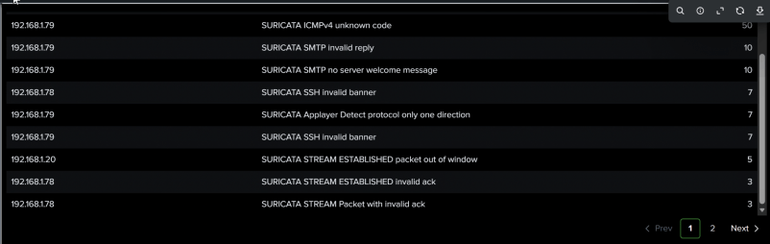
Figure 14: Alert Signature Breakdown by Destination IP

Splunk “Masters project – IDS” dashboard table panel showing the breakdown of alert signatures per source IP. The largest single category of alerts generated from the source IP address of Host 192.168.1.79 (Kali linux) as “SURICATA ICMPv4 unknown code” (50), along with “SURICATA SMTP invalid reply” (10), “SURICATA SMTP no server welcome message” (10), “SURICATA Applayer Detect protocol only one direction” (7), and “SURICATA SSH invalid banner” (7). The other source IP, 192.168.1.78 (target host), produces “SURICATA SSH invalid banner” (7), “SURICATA STREAM ESTABLISHED invalid ack” (3), and “SURICATA STREAM Packet with invalid ack” (3), whereas 192.168.1.20 (host) registers a single “SURICATA STREAM ESTABLISHED packet out of window” alert (5). The breakdown above clearly indicates that the anomaly/protocol violation alerts have been generated due to the specific source-destination IP addresses used for attacking.
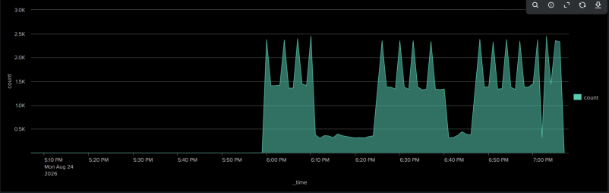
Figure 15: Zeek Event Volume Over Time

Zeek event volume timeline graph for the Splunk "Masters project – IDS" dashboard, covering the approximate timeframe. This graph depicts three clearly defined high-volume plateaus, with each plateau followed by steep spikes reaching from a base level of about 1.5K events to levels of about 2.5K events. Each plateau is separated from its neighbouring ones by two troughs with lower volumes of activity (about 5-6K events). The spike and trough pattern is characteristic of a structured, round-based nature of the attack script, with the plateaus corresponding to scanning and brute-forcing phases (similar to the Nmap and Hydra rounds mentioned previously), and the troughs representing brief pauses between each round execution.
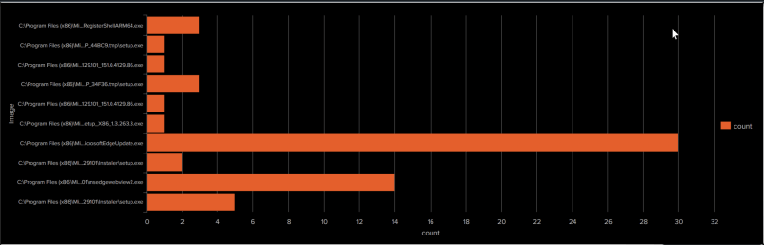
Figure 16: Sysmon Process Creation Events

The above-mentioned panel serves as a perfect example in the context of the statement mentioned above. All those processes –MicrosoftEdgeUpdate.exe, Edge WebView2 installer components, as well as several different versioned _tmp\setup.exe executables – represent perfectly normal, legitimate auto-update processes carried out via Windows/Edge (without any relation to the brute force and port scan activity). Such processes are automatically logged by Sysmon (process creation, EventCode 1) as part of routine software maintenance activities, thus appearing in the endpoint telemetry volume alongside attack activity despite being absolutely irrelevant in the context of security. This serves as a good illustration of a “noise” or “false positive filtering” discussion: it proves that Sysmon volume (13,150 events, as can be seen from sourcetype table above) consists of events that have nothing to do with attacks.
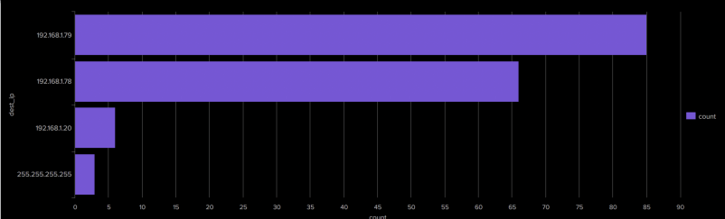
Figure 17: Alert Count by Destination IP

Bar chart of Alert Destination IP from Splunk "Masters project – IDS" Dashboard. Sorting the dest_ip based on the total Suricata Alert Count. 192.168.1.79 is receiving the highest number of alerts which is around 85, then 192.168.1.78 getting approximately 66 alerts and 192.168.1.20 with very few alerts which are about 6 and finally the 255.255.255.255 with few alerts. It must be interesting to note that 192.168.1.79 is the attacking machine Kali itself and the presence of the 192.168.1.79 as the highest alert dest_ip instead of alert src_ip could mean that the capture traffic may have both the directions as well as reset packets sent back to attacker as well.
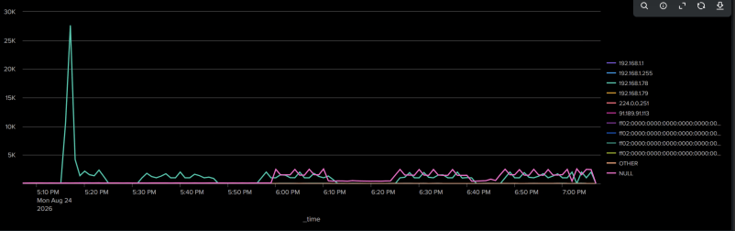
Figure 18: Zeek Event Volume Over Time by Destination IP

Multiple Time Series Plot from Splunk “Masters project – IDS” dashboard, showing the number of events by time split by IP Address (IPs include 192.168.1.1, 192.168.1.255, 192.168.1.78, 192.168.1.79, Multicast address 224.0.0.251, External IP similar to 91.189.91.113, various IPv6 Link-Local Multicast Addresses (ff02::...), Aggregated “OTHER” series, and “NULL” series for events with no corresponding entry in the split field). The key element is the distinct spike in the 192.168.1.78 time series (in green), reaching a peak of around 27K events before falling off to near-baseline levels again; this is orders of magnitude greater than anything else on this chart, and must represent the first wave of scanning/connection activity against that particular machine. There’s another distinct oscillating behaviour, dominated by the “NULL” series (in pink) with a few smaller multicast and link-local series following along, exhibiting the same
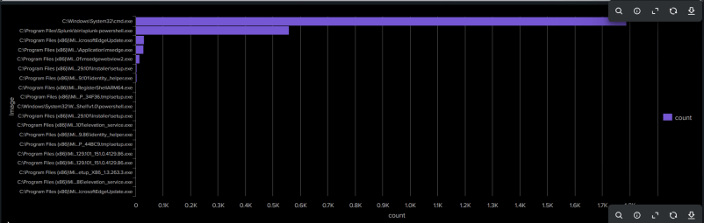
Figure 19: Sysmon Process Image Counts (All Event Types)

Bar chart of Sysmon process image from Splunk “Masters project – IDS” dashboard but this time in a much bigger scale compared to the previous one. "C:\Windows\System32\cmd.exe" is a clear winner with close to 1.7K events followed by "Splunk-powershell.exe" (PowerShell modular input of the Splunk universal forwarder) with 550 events. All other processes — MicrosoftEdgeUpdate.exe, application-manager and identity-helper services, PowerShell (Windows PowerShell\v1.0\powershell.exe), setup/installer executables, and elevation service processes — have very low numbers of events, each under 20-30.
It is quite obvious that extreme predominance of cmd.exe is a major difference compared to the previous Sysmon panel where MicrosoftEdgeUpdate.exe was winning with just 30 events — it means that cmd.exe processes are the main signals on the endpoint, possibly created as a result of the SSH sessions and attacks, this panel can be a better choice to present in the Results section as evidence of host activities triggered by attackers.
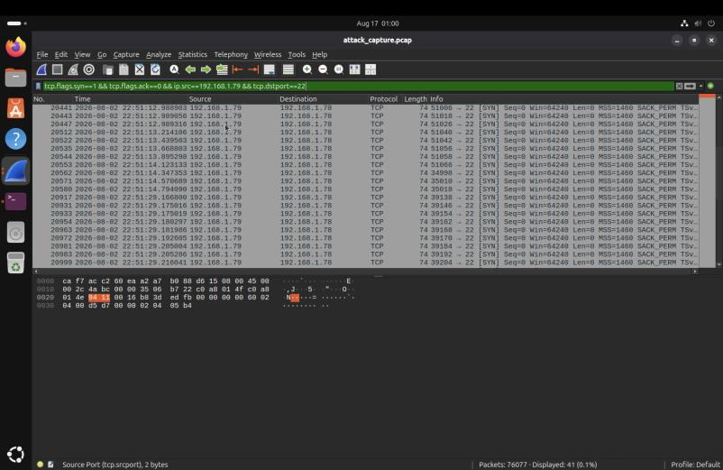
Figure 20: tcp packets captured by Wireshark

The Wireshark capture display of the attack_capture.pcap, with a filter of tcp.flags.syn==1 && tcp.flags.ack==0 && ip.src==192.168.1.79 && tcp.dstport==22, to show all outbound SSH connection attempts initiated from the attacker host. The filter cuts down the total captured packets into packets containing SYN, where 192.168.1.79 initiates new TCP connection to 192.168.1.78 on port 22 with a sequence number of 0 and window size of 64240 and default TCP options (MSS 1460, SACK_PERM, and timestamp). It can be observed from the packet list that the SYNs come in tight bursts, like the five packets occurring within one second, which is consistent with the burst-like connection attempts made during Hydra attacks. The bottom pane shows the raw hexadecimal/ASCII representation of the current frame with Ethernet and IP header fields highlighted.
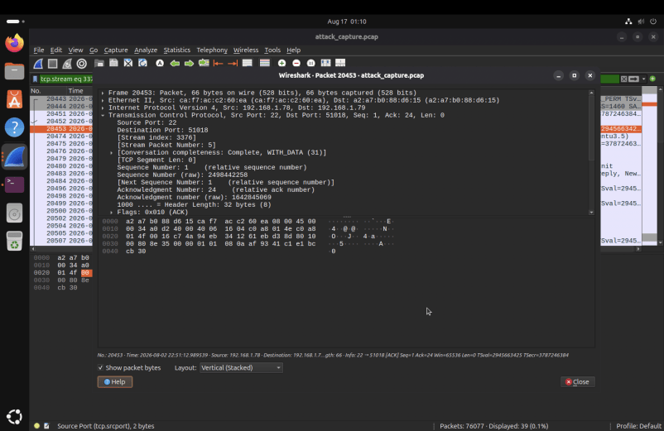
Figure 21: Wireshark Packet-Level Detail of SSH Handshake ACK (TCP Stream 3376)

Packet Detail View of Frame No. 20453 in file attack_capture.pcap obtained by filtering for Stream #3376 using tcp.stream eq 33 and focusing on "Transmission Control Protocol" layer. The packet is an acknowledgement message from the target host 192.168.1.78 (port 22) to the attacker 192.168.1.79 (port 51018) captured sequence number 1, acknowledgment number 24 (relative), 32 byte header, window size 63536, with the ACK flag set, and a zero length payload. The Ethernet layer confirms that the frame originates from the MAC address a2:a7:c2:60:e6 (192.168.1.78) to the MAC address ca:f7:ac:c2:60:ea (192.168.1.79), and the Packet Bytes pane below shows the raw hex representation of the selected TCP header fields. This packet detail view proves that the target host responded actively to the TCP connection requests by completing a part of the TCP handshake process. This packet detail view satisfies the "packet-level analysis" validation requirement.
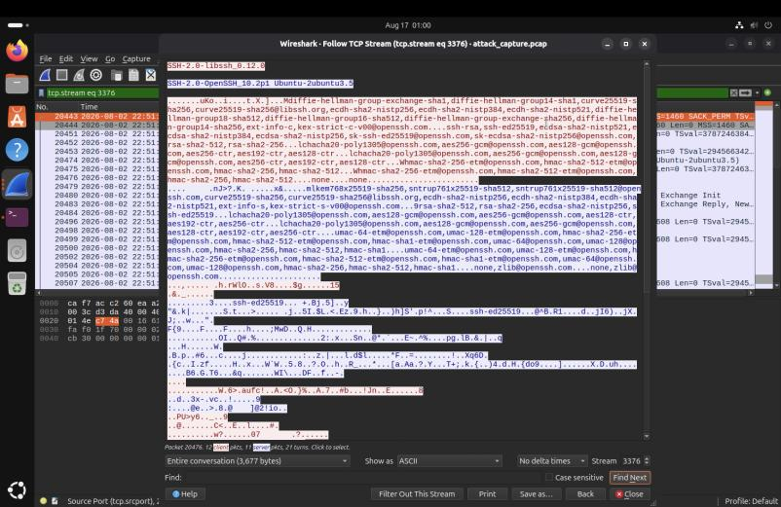
Figure 22: invalid banner(ssh)

Wireshark's "Follow TCP Stream" representation of stream number 3376 from the file "attack_capture.pcap", showing the complete SSH handshake between the attacker and the target. The SSH client identifies itself as "SSH-2.0-libssh_0.12.0" -- a clear indication that this is not an OpenSSH but a libssh-based client, which corresponds to the Hydra attack tool -- whereas the SSH server reports its version as "SSH-2.0-OpenSSH_10.2p1 Ubuntu-3ubuntu3.5". After this version announcement, both parties negotiate SSH key exchange algorithms (diffie-hellman-group-exchange-sha1, curve25519-sha256, ecdh-sha2-nistp256), ciphers.
Figure 23: PowerShell Query of Sysmon Logs for Attacker IP Activity

Execution of PowerShell command on Windows endpoint (PS C:\WINDOWS\system32>) to filter the Sysmon operational event logs that mention the attacker’s IP. The command Get-WinEvent -LogName "Microsoft-Windows-Sysmon/Operational" -MaxEvents 6976 | Where-Object {$_.Message -like "*192.168.1.79*"} | Select-Object Time Created, Id, Message finds and selects at most 6,976 Sysmon events where their messages mention the IP 192.168.1.79 (Kali attacker host), along with their timestamps, IDs and messages. It shows how to correlate the logs based on the host and find events that can be clearly attributed to the attacking IP, compared to the network detections displayed in the Suricata and Zeek tabs.

Conclusion
The findings shown in Figures will illustrate the full operation of the monitoring stack, from detection to correlation in Splunk and packet validation. After the captions of the figures above are finalised, this part of the paper will have to be expanded by adding a discussion on the detection rate, the false positive rate, the average time for detection, and investigation quality with respect to the objectives listed in Table 6.

Conclusions and future work
The present research will deal with one of the problems experienced by organisations of any sizes, which consists of detecting sophisticated attacks on bigger network infrastructure when there is limited budget for security. The present research proposes combining some free-of-charge tools (Suricata, Zeek, Sysmon, and Splunk), which make up for each other’s deficiencies, with Splunk doing automatic event correlation, where separate unobtrusive events form an evident story when correlated together.

Overview
This chapter highlights the results of the project, reviews the practical aspects of the implementation, and gives recommendations for future work.
Specific emphasis was made on the practical feasibility of the design: all the software runs under UTM virtualization from a regular MAC, all the tools are free to download, and the attack scenarios involve the same tools which the attackers employ in practice, thus making the results realistic instead of artificial. The criteria of evaluation were selected in order to make them correspond to what would actually affect the performance of the system.
The key idea of this study is that small organizations don’t need to make a choice between complete lack of monitoring capabilities and high costs associated with commercial products. With the correct configuration of an open-source software stack, it is possible to operate an entire Security Operations Centre without any licensing costs.
The two future avenues recommended in this respect are as follows: First, the development of machine learning systems that can identify anomalies that do not fit into any signatures; and secondly, the scaling of this architecture to accommodate networks more complicated than the four-host test bed employed in this project.

Future Work
The three potential paths forward for this work include: (1) optimizing the rules of Suricata by applying rate-based detection to address the high false positive rate of 66.8%; (2) combining machine learning-based detection to identify attacks based on behaviour and not signatures; and (3) correlating events between Suricata, Zeek, and Sysmon in order to avoid cross-tool alerts from redundant detections.

Reducing the False Positive Rate through Rule Tuning and Threshold-Based Detection
The existing algorithm demonstrated a false positive ratio of approximately 66.8% for the overall number of alerts triggered, being primarily determined by generic anomalies of the network protocol level (for example, "ICMPv4 unknown code", "Ethertype unknown") and not related to any generated attack traffic. The future research could include:
Building the baselines for the normal network behaviour to detect the difference between the regular traffic (for instance, neighbour discovery messages within IPv6, multicast announcements and hypervisor generated ICMP) and abnormal one, and suppress such known "benign" signatures.
The ability to disable or limit tuning on low-value default signatures that regularly match on harmless virtualised traffic, by substituting the out-of-the-box default rules of Suricata for a customised, environment-appropriate ruleset tested against the lab's traffic.
Use of rate-based and threshold-based detection rules (e.g., detection_filter and threshold of Suricata) for detection of reconnaissance behaviour such as frequent port scanning and repeated failed authentication attempts, which is a known deficiency in the out-of-the-box default rules as revealed by this project.

Resolving Alert Overlap and Cross-Tool Noise
Current architecture consumes data from Suricata, Zeek, and Sysmon in an independent manner and may result in some duplicate alerts due to the same event being reported by two systems (e.g., logging of SSH connection attempt using Suricata alert engine and Zeek connection log). To resolve this problem in future work, it is recommended to implement:
Event correlation and de-duplication in Splunk based on a common field that allows correlating events coming from several sensors into one correlated incident and not creating redundant independent alerts.
Sensor precedence where, for a specific type of an event, output from one of the tools is considered authoritative and outputs from other tools are considered additional proof instead of creating a new alert.
Using of common event schema (for example, OSSEM or custom normalised schema) to standardise data coming from different sources in terms of field names and types. For example, it would be easier to correlate events if there was always a "source IP" and "destination IP" fields in the events.

Application of Machine Learning for Behavioural and Anomaly-Based Detection
This signature-based detection system by its nature is reactive and cannot detect novel and hard-to-detect attack patterns such as a slow, distributed reconnaissance. In future versions of this solution, the following enhancements based on machine learning might be incorporated:
An unsupervised anomaly detection method (for example, clustering and autoencoders) can be applied to Zeek connection log in order to develop a behavioural profile of a 'normal' host and network traffic and highlight significant departures from the norm without the need for a signature.
Supervised classification model can be developed on labelled dataset with both attack traffic of this project and normal traffic to differentiate the true positive alerts from the false ones at the SIEM correlation phase, which is one of the findings of this project.
The time series and rate-based models could help detect brute-force and scanning behaviour by detecting specific connection frequency and inter-arrival-time patterns per host instead of using threshold.
These models could be incorporated into Splunk through, for example, Splunk Machine Learning Toolkit for the development of behavioural scoring.

Conclusion
This project has demonstrated that the integration of Suricata, Zeek, Sysmon and Splunk into one correlated logging toolset, with packet-level verification, enables small companies to have access to an affordable, free method of security visibility.

References

[1] M. Roesch, "Snort – Lightweight intrusion detection for networks," in Proc. 13th USENIX Conf. System Administration Seattle, USA, Nov. 1999, pp. 229–238.
[2] V. Paxson, "Bro: A system for detecting network intruders in real-time," Computer Networks, vol. 31, no. 23–24, pp. 2435–2463, Dec. 1999. doi: 10.1016/S1389-1286(99)00112-7
[3] S. Garcia, A. Parmisano, and M. J. Erquiaga, “IoT-23: A labelled dataset with malicious and benign IoT network traffic,”, CVUT FEE, Prague, Czech Republic, Jan. 2020. Available: https://www.stratosphereips.org/datasets-iot23
[4] J. R. Vacca, Ed., Network and System Security, 2nd ed. Waltham, MA, USA: Syngress/Elsevier, 2013. ISBN: 978-0-12-416689-9.
[5] Splunk Inc., "Splunk documentation," Splunk Inc., San Francisco, CA, USA, 2024. [Online]. Available: https://docs.splunk.com
[6] Open Information Security Foundation (OISF), "Suricata documentation," OISF, 2024. Available: https://suricata.io/documentation
[7] Microsoft, "Sysmon – Windows system monitor," Microsoft Learn, Redmond, WA, USA, 2023. Available: https://learn.microsoft.com/en-us/sysinternals/downloads/sysmon
[8] I. Sharafaldin, A. H. Lashkari, and A. A. Ghorbani, "Toward generating a new intrusion detection dataset and intrusion traffic characterization," in Proc. 4th Int. Conf. Information Systems Security and Privacy (ICISSP), Funchal, Madeira, Portugal, Jan. 2018, pp. 108–116. doi: 10.5220/0006639801080116
[9] G. Creech and J. Hu, “A semantic approach to host-based intrusion detection systems using contiguous and discontiguous system call patterns,” IEEE Transactions on Computers, vol. 63, pp. 807–819, 2014, doi: 10.1109/TC.2013.13.
[10] S. Noel and S. Jajodia, “Managing attack graph complexity through visual hierarchical aggregation,” in VizSEC/DMSEC ’04: Proceedings of the 2004 ACM Workshop on Visualization and Data Mining for Computer Security, Association for Computing Machinery, 2004, pp. 109–118. doi: 10.1145/1029208.1029225.
[11] S. Axelsson, “The Base-Rate Fallacy and the Difficulty of Intrusion Detection,” ACM Transactions on Information and System Security, vol. 3, pp. 186–205, Aug. 2000, doi: 10.1145/357830.357849.
[12] The Zeek Project, "Zeek documentation," 2024.Available: https://zeek.org/documentation
[13] M. Tavallaee, E. Bagheri, W. Lu, and A. A. Ghorbani, “A detailed analysis of the KDD CUP 99 data set,” in IEEE Symposium on Computational Intelligence for Security and Defense Applications, CISDA 2009, Dec. 2009. doi: 10.1109/CISDA.2009.5356528.
[14] A. Valdes and K. Skinner, “Adaptive, model-based monitoring for cyber-attack detection,” in Lecture Notes in Computer Science, Springer Verlag, 2000, pp. 80–93. doi: 10.1007/3-540-39945-3_6.
[15] E. Albin and N. C. Rowe, “A realistic experimental comparison of the Suricata and Snort intrusion-detection systems,” in Proceedings - 26th IEEE International Conference on Advanced Information Networking and Applications Workshops, WAINA 2012, IEEE Computer Society, 2012, pp. 122–127. doi: 10.1109/WAINA.2012.29.
[16] N. Hubballi and V. Suryanarayanan, “False alarm minimization techniques in signature-based intrusion detection systems: A survey,” Aug. 2014, Elsevier. doi: 10.1016/j.comcom.2014.04.012.
[17] A. Shiravi, H. Shiravi, M. Tavallaee, and A. A. Ghorbani, “Toward developing a systematic approach to generate benchmark datasets for intrusion detection,” Computer Security, vol. 31, pp. 357–374, May 2012, doi: 10.1016/j.cose.2011.12.012.
[18] M. Ring, S. Wunderlich, D. Scheuring, D. Landes, and A. Hotho, “A survey of network-based intrusion detection data sets,” Sep. 2019, Elsevier Ltd. doi: 10.1016/j.cose.2019.06.005.
[19] R. Sommer and V. Paxson, “Outside the closed world: On using machine learning for network intrusion detection,” in Proceedings - IEEE Symposium on Security and Privacy, 2010, pp. 305–316. doi: 10.1109/SP.2010.25.

Appendix 1: Code listing

Splunk Search Processing Language (SPL) Queries Used to Build the IDS Dashboard

- index=main sourcetype=("suricata","zeek","WinEventLog:Microsoft-Windows-Sysmon/Operational") | stats count by sourcetype | sort – count
- index=main sourcetype=suricata event_type=alert| stats count by alert.signature | sort – count | head 5
- index=main sourcetype = ("suricata", "zeek", "WinEventLog:Microsoft-Windows-Sysmon/Operational")| timechart span=1m count
- index=mainsourcetype="WinEventLog:Microsoft-Windows-Sysmon/Operational" EventCode=1| stats count by Image| sort - count| head 10
- index=main sourcetype=suricata event_type=alert| stats count by dest_ip| sort – count
- index=main sourcetype=zeek| timechart span=1m count by dest_ip limit=10
- index=main sourcetype=suricata event_type=alert| stats count by dest_ip, alert.signature| sort – count
- index=main sourcetype="WinEventLog:Microsoft-Windows-Sysmon/Operational" | stats count by Image| sort - count| head 15

Appendix 2: Project Timeline and Task Schedule

This appendix records the planned project timeline, task schedule, and Gantt chart referenced in Chapter 4.

Overview
The project runs from 1 March 2025 to 22 August 2025, a total of 24 weeks, comprising ten activities that progress broadly from reading and planning through to writing and documentation. Several activities deliberately overlap so that the output of one can benefit another: for example, packet analysis proceeds in parallel with correlation rule development.

Task Schedule

Table 7 : Project task schedule (1 March – 25 August 2025)
Task | Description | Start | End | Duration
1. Literature Review | Read existing research on SIEM, IDS, and packet analysis; identify what this project adds | 01-Mar-25 | 28-Mar-25 | 4 weeks
2. System Design | Design the architecture; decide how the tools connect and how data flows between them | 24-Mar-25 | 11-Apr-25 | 3 weeks
3. Environment Setup | Set up VMware; install Kali Linux, Ubuntu, and Windows 10/11 virtual machines | 07-Apr-25 | 25-Apr-25 | 3 weeks
4. Tool Installation & Config | Install and configure Suricata, Zeek, Sysmon, Splunk, and the packet capture tools | 21-Apr-25 | 16-May-25 | 4 weeks
5. Attack Simulation | Run the controlled attacks: Nmap port scans, Hydra brute-force, Metasploit exploitation | 12-May-25 | 30-May-25 | 3 weeks
6. Data Collection & Integration | Collect logs from all tools; set up Splunk forwarders; check data is arriving correctly | 26-May-25 | 13-Jun-25 | 3 weeks
7. Analysis & Correlation | Write SPL correlation rules; tune alert thresholds; test that alerts fire correctly | 09-Jun-25 | 04-Jul-25 | 4 weeks
8. Packet Investigation | Use Wireshark and tcpdump to validate alerts and document the forensic process | 30-Jun-25 | 18-Jul-25 | 3 weeks
9. Evaluation & Testing | compare single-source vs integrated results | 14-Jul-25 | 01-Aug-25 | 3 weeks
10. Documentation & Reporting | Write up the methodology, results, and conclusions in the final project report | 28-Jul-25 | 25-Aug-25 | 4 weeks

Gantt Chart
Table 8 : Project Gantt chart (1 March – 25 August 2025)
Project Name | Student Name | Student ID | Start Date | End Date
SIEM-Based IDS & Network Threat Detection with Packet-Level Analysis | Gnanadeep Chittineni | 25267604 | 1-3-2025 | 25-8-2025
The schedule below reproduces the task start and end dates from the original Gantt chart
SIEM-Based IDS & Network Threat Detection |  |  | Gnandanep Chittineni |  | 25267604 |  | 1-3-2025 |  | 25-8-2025
PROJECT NAME |  |  | STUDENT NAME |  | STUDENT ID |  | START DATE |  | END DATE
Task Name | Start Date | End Date | 1-Mar | 15-Mar | 29-Mar | 12-Apr | 26-Apr | 10-May | 24-May | 7-Jun | 21-Jun | 5-Jul | 19-Jul | 2-Aug | 16-Aug | 30-Aug
Literature Review | 01-Mar-25 | 14-Mar-25
System Design | 10-Mar-25 | 28-Mar-25
Environment Setup | 24-Mar-25 | 11-Apr-25
Tool Install & Config | 07-Apr-25 | 25-Apr-25
Attack Simulation | 21-Apr-25 | 09-May-25
Data Collection | 05-May-25 | 23-May-25
Analysis & Correlation | 19-May-25 | 20-Jun-25
Packet Investigation | 16-Jun-25 | 11-Jul-25
Evaluation & Testing | 07-Jul-25 | 01-Aug-25
Documentation | 28-Jul-25 | 22-Aug-25

Critical Path and Dependencies
This is the crucial sequence: Task 3 (preparation of the environment), Task 4 (installation and configuration of the tools), Task 5 (conducting the attacks), Task 6 (collection of the results), and Task 7 (design of the correlation rules). Each next task depends on the completion of the previous one, so that the delay in any of these stages will have an effect on the entire schedule.
In contrast, Tasks 1 (preliminary research and design) and 10 (report writing) are more flexible and will not be influenced by any delays. Beginning Task 1 in March rather than in April as originally planned will give some time for brainstorming of the system design prior to beginning Task 2 in April. Tasks 7 and 8 should be done simultaneously, as analysis of the packets capture improves correlation rule development, and correlation rule development allows for better analysis of the packets captures.

